Abstract Diction
Here’s a full breakdown of:

☁️ What is Abstract Diction
# Source: Chatgpt (GPT-4-turbo) at [7/30/2025]
Abstract diction refers to the use of words that express intangible ideas, qualities, emotions, or concepts—things that cannot be directly seen, touched, or measured.

✅ Key Features:
# Source: Chatgpt (GPT-4-turbo) at [7/30/2025]
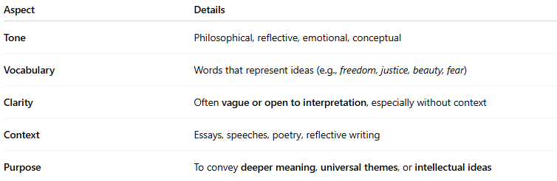
Aspect | Details
Tone | Philosophical, reflective, emotional, conceptual
Vocabulary | Words that represent ideas (e.g., freedom, justice, beauty, fear)
Clarity | Often vague or open to interpretation, especially without context
Context | Essays, speeches, poetry, reflective writing
Purpose | To convey deeper meaning, universal themes, or intellectual ideas

🧠 Examples of Abstract Words:
# Source: Chatgpt (GPT-4-turbo) at [7/30/2025]
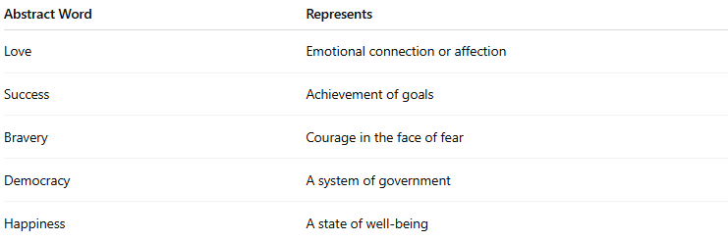
Abstract Word | Represents
Love | Emotional connection or affection
Success | Achievement of goals
Bravery | Courage in the face of fear
Democracy | A system of government
Happiness | A state of well-being

✍️ Example Sentences Using Abstract Diction:
# Source: Chatgpt (GPT-4-turbo) at [7/30/2025]
- “She longed for freedom, even if it meant leaving everything behind.”
- “His actions were guided by honor, not ambition.”
- “They struggled to define what justice truly meant.”

🔍 Abstract vs. Concrete Diction:
# Source: Chatgpt (GPT-4-turbo) at [7/30/2025]
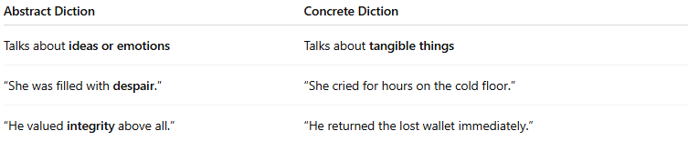
Abstract Diction | Concrete Diction
Talks about ideas or emotions | Talks about tangible things
“She was filled with despair.” | “She cried for hours on the cold floor.”
“He valued integrity above all.” | “He returned the lost wallet immediately.”

🧭 Used In:
# Source: Chatgpt (GPT-4-turbo) at [7/30/2025]
- Philosophy, literature, essays
- Poetry and political speeches
- Psychological or moral analysis

